An arithmagon is a polygon with numbers at its vertices which determine the numbers written on its edges. Usually, we add the numbers at the vertices to find the numbers on the edges, but for these arithmagons, we multiply.

Fill in the missing numbers in these arithmagons.
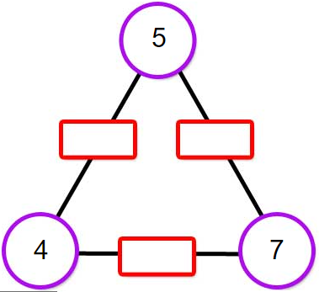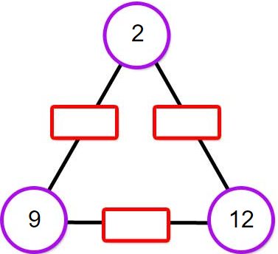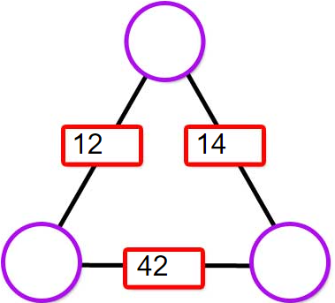

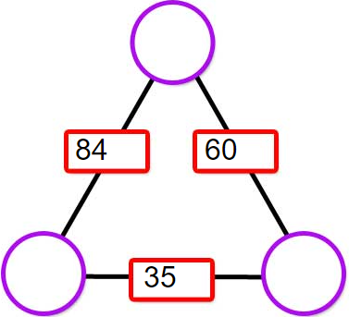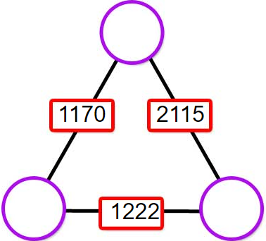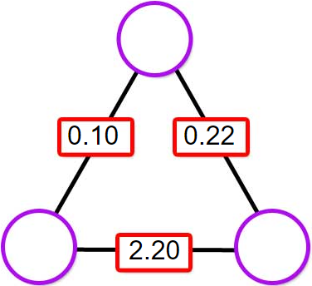
You could also make up some of your own for a partner to solve.

Once you are confident that you can work out the values at the vertices efficiently, here are some questions you might like to consider:

- Can you describe a strategy to work out the values at the vertices irrespective of the values given for the edges?
- Is there a relationship between the product of the values at the vertices and the product of the values on the edges?
- What happens to the numbers at the vertices if you double (or treble, or quadruple...) one or more of the numbers on the edges?
- Can you create a multiplication arithmagon with fractions at some or all of the vertices and whole numbers on the edges?

